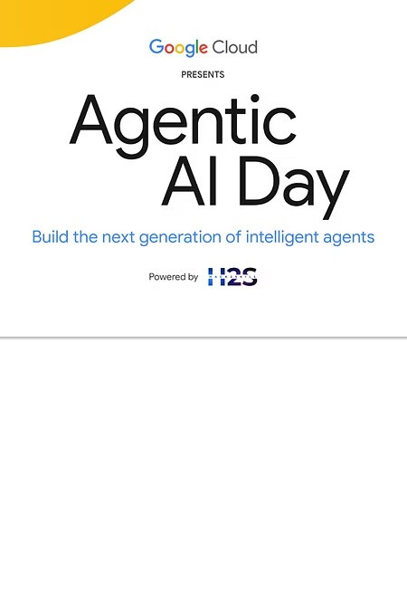

# Bhu-Rakshak: Smart Irrigation Framework

Revolutionizing agricultural water management with IoT, AI, and autonomous drone technology.

**Team:** Rama, Srinivas

**Team Leader:** O(N) square

**Problem Statement:** Bhu-Rakshak

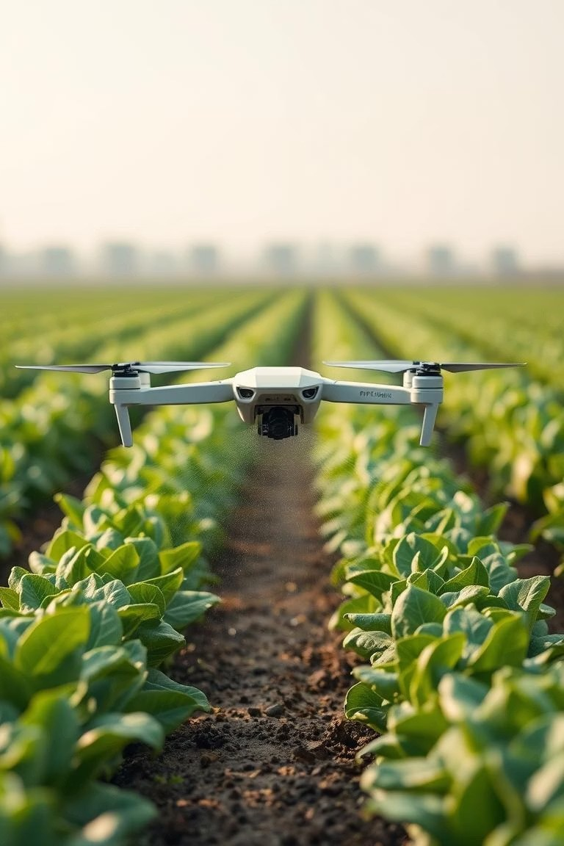

# Bhu-Rakshak: A Smart Irrigation Solution

The "Bhu-Rakshak" project proposes a pioneering smart irrigation framework that utilizes the Internet of Things (IoT), Artificial Intelligence (AI), and autonomous drone technology to revolutionize agricultural water management.

The system aims to create a smart, autonomous, and data-driven ecosystem to ensure optimal resource utilization, enhance crop yield, and promote environmental sustainability. It addresses the challenge of inefficient water management in agriculture, which contributes to water scarcity, soil degradation, and suboptimal crop yields.

Bhu-Rakshak collects real-time data from in-field soil sensors and meteorological sources, processes it through advanced predictive machine learning models, and executes precise, automated irrigation using a fleet of intelligent drones. This approach represents a paradigm shift towards precision agriculture, promising to significantly reduce water consumption, boost agricultural productivity, and enhance the resilience of food supply chains.

[](https://gamma.app/?utm_source=made-with-gamma)

# Opportunities & Differentiation

## Opportunities

 **Farmers:** Increased profitability through higher yields and lower resource costs.

 **Governments:** Tool for water conservation, drought mitigation, and food security.

 **Tech Partners:** Groundbreaking AI/IoT application, opening new markets.

## Differentiation

 **Integrated AI:** Predictive model augmented by LLM with RAG for context-aware decisions.

 **Autonomous Drones:** Precise data analytics with targeted water delivery.

 **Microservices:** Built for resilience, scalability, and future integration.

[](https://gamma.app/?utm_source=made-with-gamma)

# Problem Solving & USP

## Problem Solving

 **Reduce Water Waste:** Cuts down the estimated 50% water wastage in traditional irrigation.

 **Boost Productivity:** Optimal resource utilization and targeted irrigation lead to healthier crops and significantly higher yields.

 **Enhance Food Security:** Strengthens the resilience of food supply chains against climate change and resource depletion.

USP

 **Intelligent Precision Agriculture:** A unique blend of granular IoT data, advanced AI (ML + RAG-LLM), and autonomous drone technology for highly accurate and adaptive irrigation.

 **Sustainable & Economically Viable:** Delivers significant environmental benefits (water conservation) alongside tangible economic returns for farmers.

 **Scalable and Future-Ready Platform:** Designed as an "operating system" for precision agriculture, capable of integrating future innovations like pest and nutrient management.

[](https://gamma.app/?utm_source=made-with-gamma)

# Solution Features: Data Acquisition & Analytics

#### Intelligent Data Acquisition:

 Continuous monitoring of soil moisture levels using in-field capacitive and resistive sensors.  Aggregation of real-time environmental data (temperature, humidity, precipitation).

 Integration of crop-specific information (type, growth stage, water requirements).

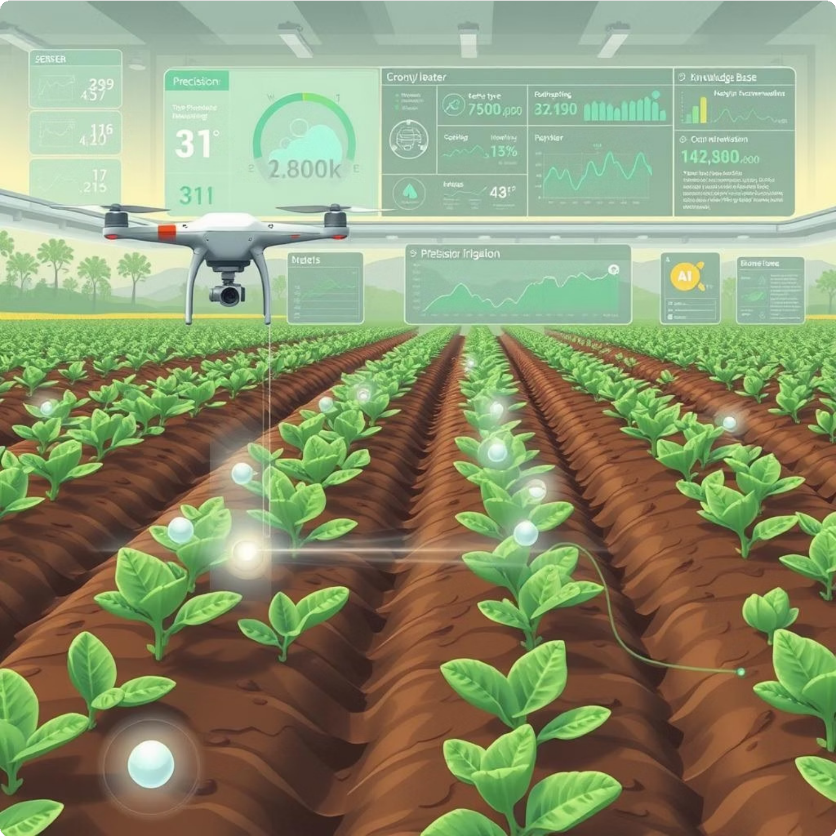

 Efficient data transmission over long distances using LoRaWAN protocol.

#### Advanced Predictive Analytics & Decision-Making:

 Sophisticated Machine Learning Engine utilizing Neural Network architectures like Long Short-Term Memory (LSTM) or Gated Recurrent Units (GRU) to forecast crop water needs.

 Integration of Large Language Model (LLM) with Retrieval-Augmented Generation (RAG) framework for enhanced decision-making and access to a vast knowledge base of agricultural research and best practices.

[](https://gamma.app/?utm_source=made-with-gamma) Dynamic Irrigation Scheduling algorithm to generate optimized irrigation plans.  Optimized Drone Flight Path generation based on AI predictions.

Solution Features: Execution & Management

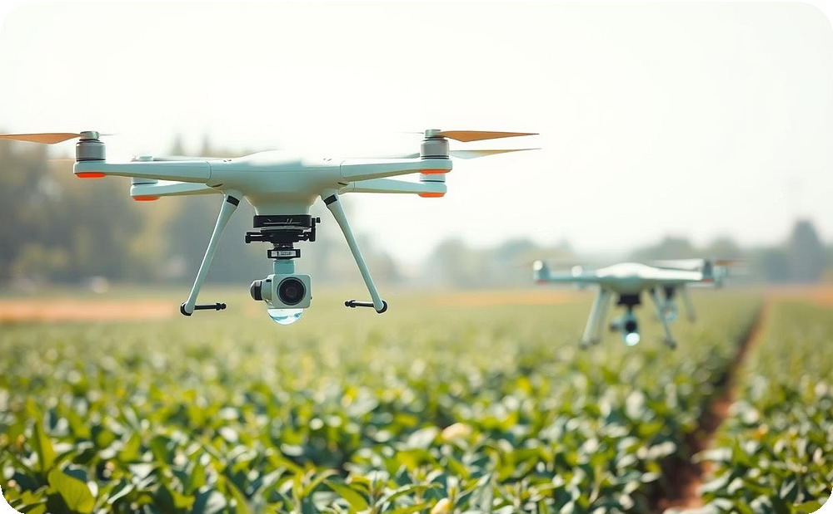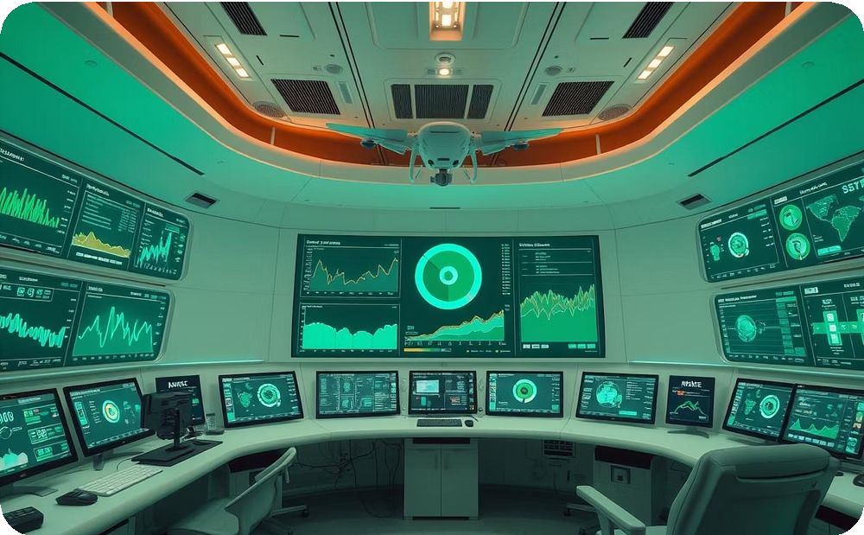

### Autonomous Execution & Irrigation

An autonomous drone fleet with GPS and water tanks precisely delivers water, eliminating manual labor and optimizing distribution. An

on-site water filtration system ensures water purity, while automatic control systems manage flight planning, obstacle avoidance, and precise water release for efficient application.

### Centralized Control & Management

A Central Control Unit aggregates data, makes decisions, and sends commands to sensors, drones, and the water filtration system, acting as the system's brain. Built on a microservices architecture, it ensures resilience, maintainability, and scalability with dedicated services for communication, batch management, drone control, and notifications. Real-time control allows dynamic adjustments to water filtration parameters.

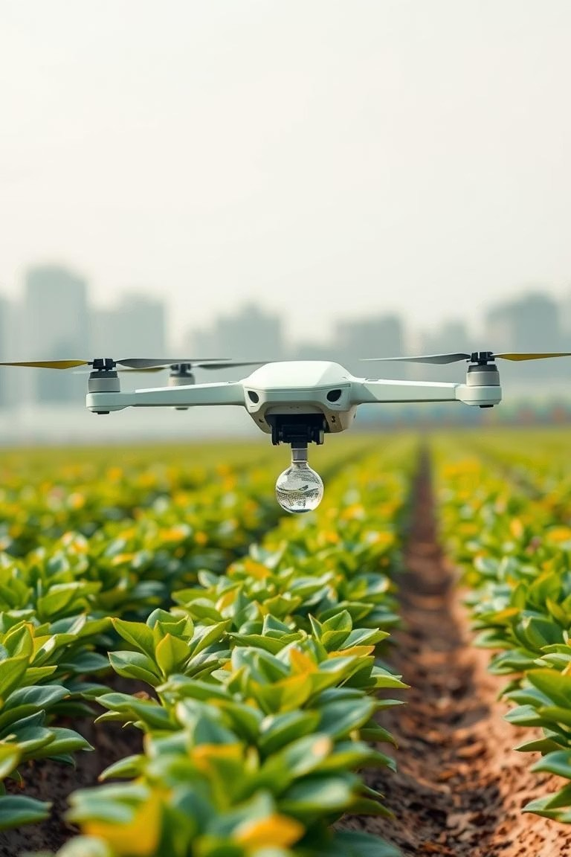

[](https://gamma.app/?utm_source=made-with-gamma)

# Process Flow Diagram

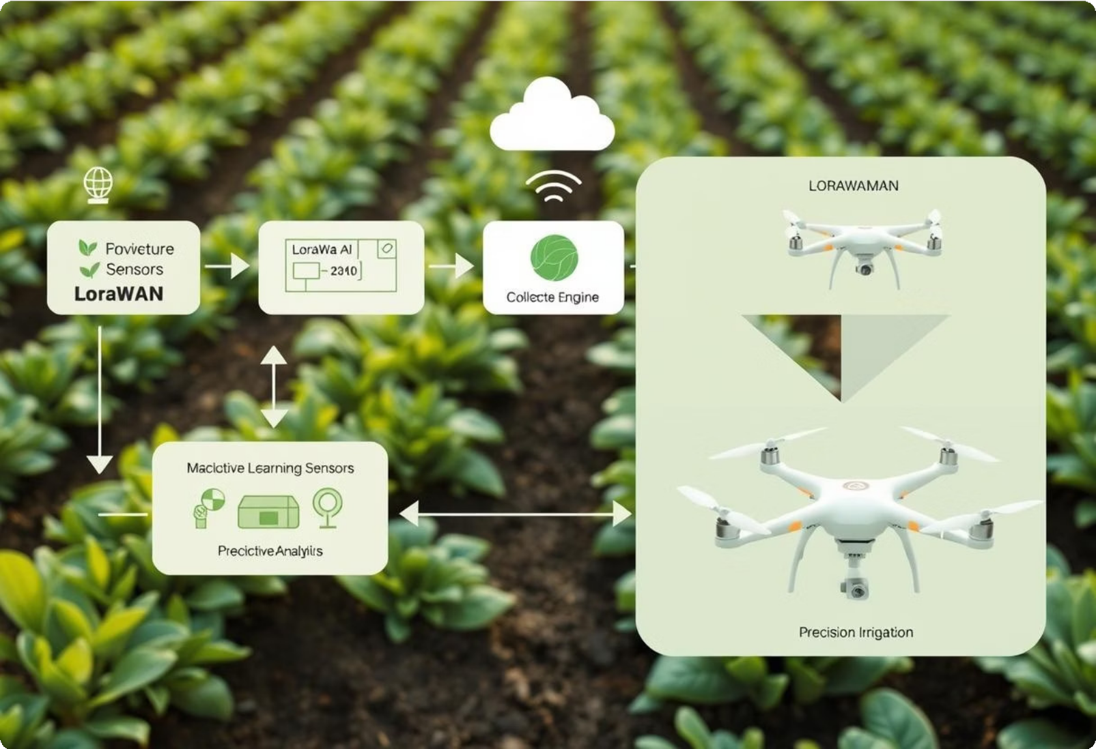

Technologies: Hardware & Communication

#### Hardware & Sensing Layer:

 **In-Field Soil Sensors:** Capacitive and resistive sensors for continuous soil moisture monitoring

 **Environmental Data Aggregation:** Integration with meteorological data sources (temperature, humidity, precipitation).

 **Autonomous Drones:** Customized agricultural drones equipped with GPS navigation and water tanks for precise irrigation.

 **Water Filtration System Components:** Including filters (e.g., sand, carbon) and water pumps

 **Central Control Unit Hardware:** Such as Raspberry Pi and microcontrollers with network interfaces

#### Communication & Data Ingestion:

 **LoRaWAN Protocol:** For low-power, long-range communication from sensor networks across vast agricultural landscapes

 **APIs:** For integrating weather and crop-specific data

 **Google Cloud Pub/Sub:** For scalable, real-time ingestion of sensor data and API feeds into the cloud environment.

[](https://gamma.app/?utm_source=made-with-gamma)

Technologies: Data & AI Core

**Data Processing & Storage:**

 **Microservices-based Architecture:** For robust, scalable, and maintainable system decomposition (e.g., communication, batch management, drone control, notification services)

 **Containerization:** Using technologies like Docker for deploying independent services.

 **Google Kubernetes Engine (GKE) / Google Cloud Run:** For orchestrating and deploying the containerized microservices and backend applications.

 **Google Cloud Storage:** For durable and scalable storage of raw and processed agricultural data, including historical sensor readings and model data.

 **Google BigQuery:** For analytics and large-scale data warehousing of agricultural datasets.

**Artificial Intelligence & Machine Learning Core:**

 **Machine Learning Engine:** Utilizing advanced neural network architectures.

 **Gated Recurrent Units (GRU):** As a computationally simpler alternative for sequential data processing.

 **Retrieval-Augmented Generation (RAG) Framework:** To enhance decision-making by querying vast knowledge bases.

 **Large Language Models (LLM):** Integrated within the RAG framework for context-specific information and unparalleled accuracy.

 **Google Vertex AI:** As a unified MLOps platform for training, deploying, and managing the predictive AI models (LSTM, GRU, RAG, LLM), covering the full ML lifecycle.

[](https://gamma.app/?utm_source=made-with-gamma) **Google Gemini:** As the Large Language Model (LLM) component within the RAG framework, providing advanced language understanding and generation capabilities for agricultural research integration.

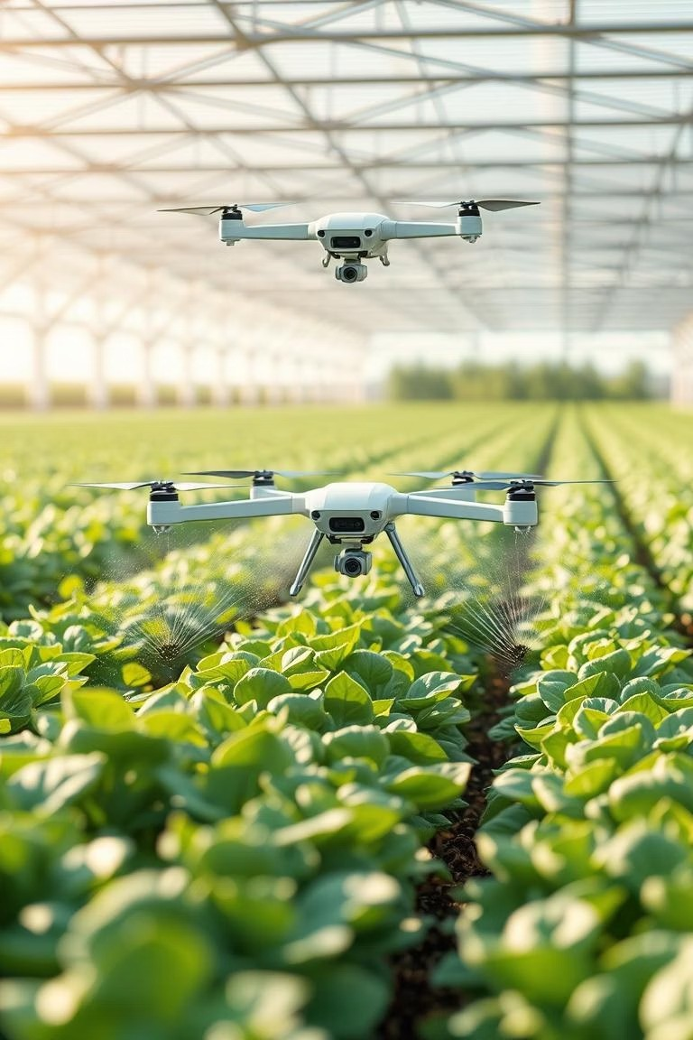

# Technologies: Control & Orchestration

#### Autonomous Control & Orchestration:

 **Intelligent Algorithms:** For dynamic irrigation scheduling and optimized drone flight path generation

 **Central Control Unit Logic:** For cohesive operation and command issuance to hardware modules

 **Firebase Cloud Messaging:** Potentially for sending system alerts and reports via the notification-service.

[](https://gamma.app/?utm_source=made-with-gamma)